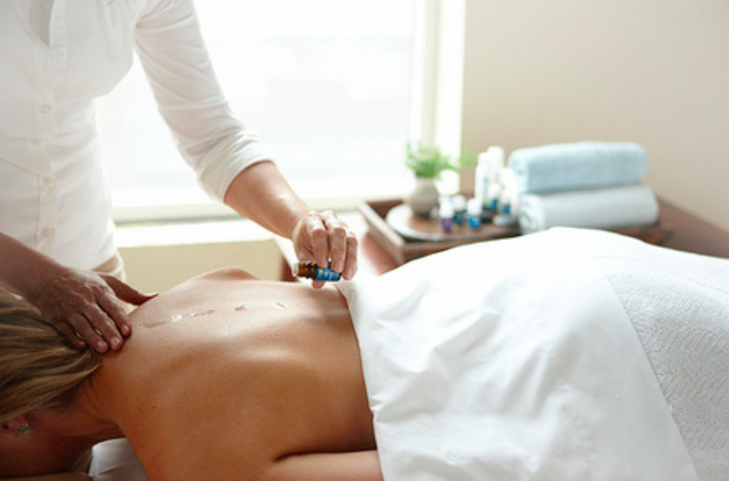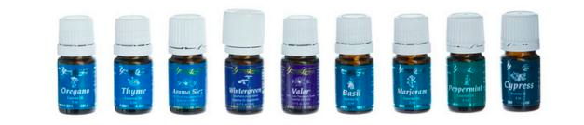

|  |  |
| --- | --- |
| * Improves spinal alignment * Enhances immunity * Cleanses the body of toxins * Relieves inflammation and pain * Unwinds tight and sore muscles, tendons, and ligaments * Balances and harmonizes the energy | * Soothes the nervous system * Produces deep relaxation * Facilitates the release of stubborn emotions * Relieves headaches * Increases energy * Promotes overall health, vitality & longevity |
|  | |

**The Raindrop Treatment & the techniques**

“Therapeutic Bodywork with Raindrop™Oils” treatment is a combination of Aromatherapy, Vita Flax Technique, Feather Stroking, Ancient Massage, Head Massage, Grounding and Young Living Raindrop Technique.

* **Aromatherapy and Young Living Raindrop Technique** – Raindrop technique uses nine essential oils during the session. It is congruent with the French application of aromatherapy where essential oils are applied NEAT (undiluted) to the body.

**\* All see below benefits of Raindrop oils**

* **Vita Flex Technique** –It is an ancient healing methodology meaning "vitality through the reflexes". Its theory is based on the fact that slight pressure applied to the body creates an electric charge that is therapeutic to the body.
* **Feather Stroking** - This is similar to a massage term technique called effleurage. When it is carried out lightly, it creates a soothing effect on the body helps it to relax and get away from physical stress; and improve the blood circulation. Short and fast massage strokes help to stimulate the muscles, thereby improving their performance.
* **Ancient Massage** - Ancient (Thai) Massage is a gentle and very effective technique in releasing blockages in the body and aligning the energies of the body.
* **Head Massage** - The aim of the Head Massage is to release the stress that has accumulated in the tissues, muscles and joints of the head, face, neck and shoulders; improves blood circulation and lymphatic flow, frees knots of muscular tension.
* **Grounding** - it is a technique to help the client to sink into calmness naturally, enabling him/her to identify and sustain the ultimate Shavasana or complete relaxation.

**Benefits of Raindrop oils**

* Restores Physical, Mental and Emotional Balance
* Improves spinal alignment issue - The use of essential oils helps to dispose of these viruses within the spine, helping its structure return to normal
* Enhances immunity
* Cleanses the body of toxins - The oils being high in phenols cleanse cellular receptor sites and enhance cleansing of the body.
* Relieves inflammation and pain
* Unwinds tight and sore muscles, tendons, and ligaments
* Balances and harmonizes the energy
* Soothes the nervous system
* produces deep relaxation
* Facilitates the release of stubborn emotions
* Relieves headaches
* Boosts stamina & increases energy
* Promotes overall health, vitality & longevity

Create your healing space and personal grounding and intend no harm

*“I invoke the Divine Universal Energies to send Healing and Balancing Frequencies to ……. For his/her healing and his/her highest good. May I be a clear and perfect channel”*

Notes

1. Never dilute an essential oil with water
2. Use only vegetable oil to dilute essential oils for potential skin sensitivity
3. If someone becomes feels uncomfortable or part of the body turns red, use pure vegetable oil on the area. Within a short time the reaction will subside.
4. Use 2-4 drops of each essential oil or blend in the treatment
5. Do not apply oregano and Thyme higher than the middle of the back (do not feather all the way to the neck)
6. Remember to breathe deeply throughout the session, for both client and therapist
7. Always tell client to drink lots of water following the treatment. This will assist them in flushing away toxins that have been released. You need to drink extra water as well.
8. Remember to enjoy giving this beautiful gilf – you cannot do it “wrong”

## Legs massage

* Rocking the bottom of the feet & massage up the leg to underwear line
* Stretch the thighs
* Massage the thighs & lift (2 inches)
* Elbow point lower back
* Same way up same way down

## Back massage

Put V-6 oil on neck and down the spine

Valor – on ears and feet

Clear blockages and create environment for healing

Oregano – feather / fan strokes

Regenerates cells, antiviral, antibacterial, antifungal, immune stimulant

Thyme – feather

Antiaging, antioxidant, anti-inflammatory, purifying

Basil – feather / circles / kneading from bottom of spine to shoulder

Eliminate toxins and hydrates the cells

Cypress – feather / sawing & rocking

Improve circulation, antioxidant, liver health

Wintergreen – feather / Vita-flex (thumb-rolling)

Anti-inflammatory, help musculoskeletal problems

Marjoram – feather / fan / kneading upper back & shoulder

Muscle soothing, remove joint discomfort

Peppermint – feather / fan

Anti-inflammatory, antiviral, antifungal

Aroma Siez (or other blend depending on client’s needs) – massage back, allows everything to work together in harmony

Improve circulation, antioxidant, liver health

Valor (optional) – feather / massage